实验（5）—— 静态 友元

学生姓名：黄伟杰 专业班级：计算机211
课程名称：面向对象程序设计 实验类型：综合

一 实验目的
练习C++静态与友元。

二 实验环境
PC机 + Windows 10操作系统 + CodeBlocks 集成开发环境

三 实验内容
1.设计一个书本销售类BookSale，包括no(编号)、name(书名)和price(价格)数据成员外，还有个静态变量num，存放卖出的书本数量，另有普通成员函数disp()，用于输出数据成员的值，另有一个静态成员函数sum()，它用于计算已卖出总金额。
#include <iostream>
#include <cstring>
using namespace std;
class BookSale {
public:
BookSale(char *_no, char *_name, int _price) {
strcpy(no, _no);
strcpy(name, _name);
price = _price;
num ++;
sumP += price;
}
void disp() {
printf("%s %s %d\n", no, name, price);
}
static void sum() {
cout << "总金额: " << sumP << '\n';
}
private:
static int num, sumP;
char no[15], name[20];
int price;
};
int BookSale::num = 0;
int BookSale::sumP = 0;
int main() {
cout << "no name price" << '\n';
BookSale t1("001", "Book1", 10);
t1.disp();
BookSale t2("002", "Book2", 20);
t2.disp();
BookSale t3("003", "Book3", 30);
t3.disp();
BookSale::sum();
return 0;
}
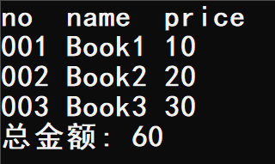
2.设计一个类，模拟一个奶茶铺，能实时统计店铺营业额。
#include <iostream>
#include <cstring>
using namespace std;
class Tea {
public:
Tea(char *_type, int _price) {
strcpy(type, _type);
price = _price;
sum += _price;
}
void disp() {
cout << type << " " << price << '\n';
}
static void out() {
cout << "当前营业额($): " << sum << '\n';
}
private:
char type[20];
int price;
static int sum;
};
int Tea::sum = 0;
int main() {
Tea t1("type1", 10);
t1.disp();
Tea::out();
Tea t2("type2", 15);
t2.disp();
Tea::out();
Tea t3("type3", 20);
t3.disp();
Tea::out();
return 0;
}
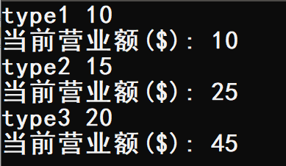
3.设计一个类，模拟大众点评，能统计某餐厅的消费均价。
#include <iostream>
#include <cstring>
using namespace std;
class Restaurant {
public:
Restaurant(char *_type, int _price) {
strcpy(type, _type);
price = _price;
cnt ++;
sum += price;
}
void disp() {
cout << type << " " << price << '\n';
}
static void out() {
cout << "当前消费均价($): " << 1.0 * sum / cnt << '\n';
}
private:
char type[20];
int price;
static int cnt, sum;
static double aver;
};
int Restaurant::cnt = 0;
int Restaurant::sum = 0;
int main() {
Restaurant t1("type1", 50);
t1.disp();
Restaurant::out();
Restaurant t2("type2", 75);
t2.disp();
Restaurant::out();
Restaurant t3("type3", 182);
t3.disp();
Restaurant::out();
return 0;
}
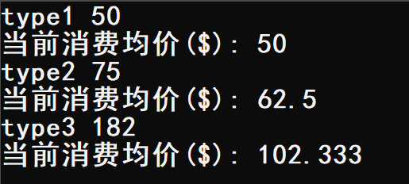
4.写一个书本类Book，包括书名、作者、出版社和价格，设计一个友元函数，能输出价格大于等于50元以上的书本信息。
#include <iostream>
#include <cstring>
using namespace std;
class Book {
public:
Book(char *_name, char *_author, char *_publish, int _price) {
strcpy(name, _name);
strcpy(author, _author);
strcpy(publish, _publish);
price = _price;
}
void disp() {
cout << name << " " << author << " " << publish << " " << price << '\n';
}
friend void out(Book t) {
if (t.price >= 50) {
cout << "该书价格大于50($): ";
cout << t.name << " " << t.author << " " << t.publish << " " << t.price << '\n';
}
}
private:
char name[20], author[20];
char publish[20];
int price;
};
int main() {
Book t1("Book1", "Mike", "0000-01", 49);
t1.disp();
out(t1);
Book t2("Book2", "Jake", "0000-02", 51);
t2.disp();
out(t2);
Book t3("Book3", "Tony", "0000-03", 88);
t3.disp();
out(t3);
return 0;
}
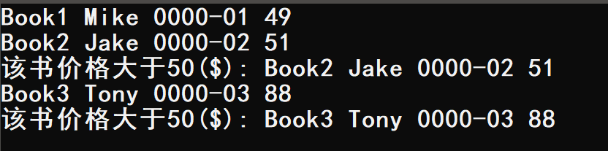
5.写一个书本类Book，包括书名、作者、出版社和价格，设计一个友元函数，比较两本书的价格高低，并返回价格较低的那本书的书名。
#include <iostream>
#include <cstring>
using namespace std;
class Book {
public:
Book(char *_name, char *_author, char *_publish, int _price) {
strcpy(name, _name);
strcpy(author, _author);
strcpy(publish, _publish);
price = _price;
}
void disp() {
cout << name << " " << author << " " << publish << " " << price << '\n';
}
friend void cmp(Book t1, Book t2) {
cout << t1.name << " vs " << t2.name << '\n';
if (t1.price > t2.price) cout << t1.name << "价格更高！" << '\n';
else if (t1.price < t2.price) cout << t2.name << "价格更高！" << '\n';
else cout << "两书价格相同！" << '\n';
}
private:
char name[20], author[20];
char publish[20];
int price;
};
int main() {
Book t1("Book1", "Mike", "0000-01", 50);
t1.disp();
Book t2("Book2", "Jake", "0000-02", 30);
t2.disp();
Book t3("Book3", "Tony", "0000-03", 50);
t3.disp();
cmp(t1, t2);
cmp(t2, t3);
cmp(t1, t3);
return 0;
}
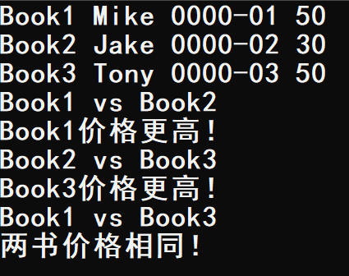
6.创建一个队列类，要求实现构造函数、判断队列是否为空、出队、入队等操作，通过数组来间接实现。并采用多文件结构。
- MyQueue.h
#ifndef _MY_QUEUE_H_
#define _MY_QUEUE_H_

const int M = 110;
class MyQueue {
public:
MyQueue();
MyQueue(int _x);
int top();
void pop();
void push(int _x);
bool empty();
void disp();
private:
int arr[M];
int head, tail;
};
MyQueue::MyQueue() {
head = 0;
tail = 0;
}
MyQueue::MyQueue(int _x) {
head = 0;
tail = 0;
arr[tail ++] = _x;
}
int MyQueue::top() {
return arr[head];
}
void MyQueue::pop() {
head ++;
}
void MyQueue::push(int _x) {
arr[tail ++] = _x;
}
bool MyQueue::empty() {
if (head == tail) cout << "队列为空！" << '\n';
else cout << "队列不为空！" << '\n';
}
void MyQueue::disp() {
for (int i = head; i < tail; i ++) cout << arr[i] << " ";
cout << '\n';
}

#endif
6.cpp
#include <iostream>
using namespace std;
#include "MyQueue.h"
int main() {
MyQueue queue(1);
queue.push(2);
queue.push(3);
queue.push(4);
queue.push(5);
queue.disp();
queue.empty();
cout << "队首元素为: " << queue.top() << '\n';
queue.pop();
queue.disp();
cout << "队首元素为: " << queue.top() << '\n';
queue.pop();
queue.disp();
cout << "队首元素为: " << queue.top() << '\n';
return 0;
}
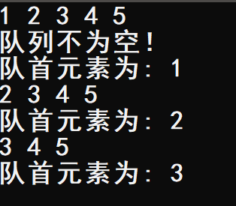
四 实验小结
巩固了C++的静态与友元。

